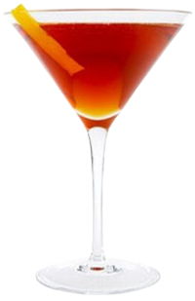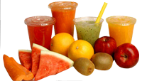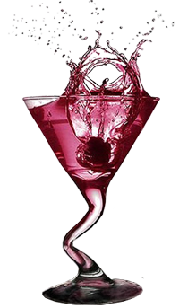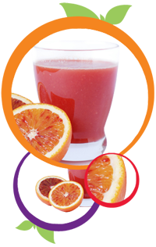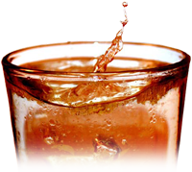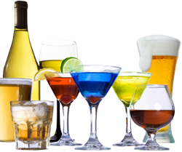

**Hot Drinks**

**Wine BY the Glass**

**Local Spirits**

Coke

Fanta (Lemon or Orange)

Sprite

Soda

Water

Tonic Water

Fruit Juice

Ayran

Ice Tea

Energy Drink

Fresh Orange

**Soft Drinks**

**Milk Shakes**

**Drinks Menu**

Red

White

Rose

Medium White

Sweet White

_____

_____

_____

_____

_____

Banana

Strawberry

Cherry

Vanilla

Chocolate

Mixed (Your Choice)

_____

_____

_____

_____

_____

_____

_____

Brandy

Vodka

Gin

Raki

Turkish Liqueur

Vodka – Redbull

Cider

Efes

Efes Light/Dark

Tuborg

Miller/Becks

Fosters/Carlsberg

John Smiths

Guinness

Cider

Budweiser/ Corona

_____

_____

_____

_____

_____

_____

_____

_____

_____

Bacardi

Malibu

Rum

Whisky

Bailesy

Tia Maria

Kahlua

Archers

Tequila

Safari

Martini

Gordon Gin

Amaretto

Smirnoff Vodka

Jack Daniels

Jim Bean

Southern Comfort

**Beers**

_____

_____

_____

_____

_____

_____

_____

_____

_____

_____

_____

_____

Bailey’s Coffee

Tia Maria Coffee

Irish Coffee

Brandy Coffee

Kahlua Coffee

Cointreau Coffee

Hot Chocolate

Nescafe

Tea

Apple Tea

Green Tea

Cappuccino

_____

_____

_____

_____

_____

_____

_____

_____

_____

_____

_____

_____

_____

_____

_____

_____

_____

**Import Drinks**

_____

_____

_____

_____

_____

_____

_____

_____

_____

_____

_____

_____

_____

_____

_____

_____

_____