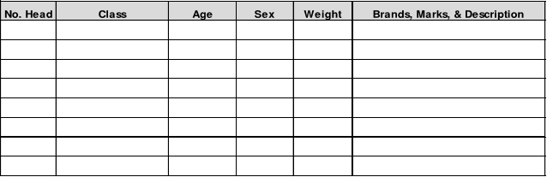Livestock Bill of Sale

Seller:

Buyer:

Printed Name: ____________________ Printed Name: ____________________

Address: ________________________ Address: ________________________

City: ____________________________ City: ____________________________

State:______________ Zip: _________ State:______________ Zip: _________

This is to certify that on this __________ day of __________________, __________,

the undersigned Seller, in consideration of the sum of $_______________________ ,

sold to the undersigned Buyer the following described livestock, the title to which the

Seller guarantees.

Seller:

_____________________________________ Date: ______________________

Buyer:

_____________________________________ Date: ______________________

